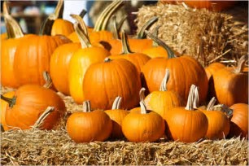  sATURDAY, oCTOBER 14, 2017  SAUVIE ISLAND REGIONAL GATHERING  Pumpkins, hay rides, hot cider!  Bella Organic is a 100 acre Certified Organic Farm located on the beautiful Sauvie Island, in the City of Portland. We will meet at the entrance & will enjoy a hay ride to the pumpkin patch, the corn maze, & lunch at the food carts together.  Please RSVP to Daisy Cheatham at dcheatham@cmasas.org by October 1, 2017 if you would like to attend. | Bring shoes you don’t mind getting muddy!  ────  All activities & food booths are cash-only!  ────  Free hay rides!  ────  Corn maze takes about an hour to figure out.  Corn maze prices:  Adult 13+ $7.00  Child 6-12 $5.00  BELLA’S ORGANIC FARM  16205 NW GILLIHAN RD.  PORTLAND, OR 97231  503-621-9545  BELLAORGANIC.COM  OCT. 14, 2018  10 AM-2 PM ( meet at front entrance by 9:45 am)

