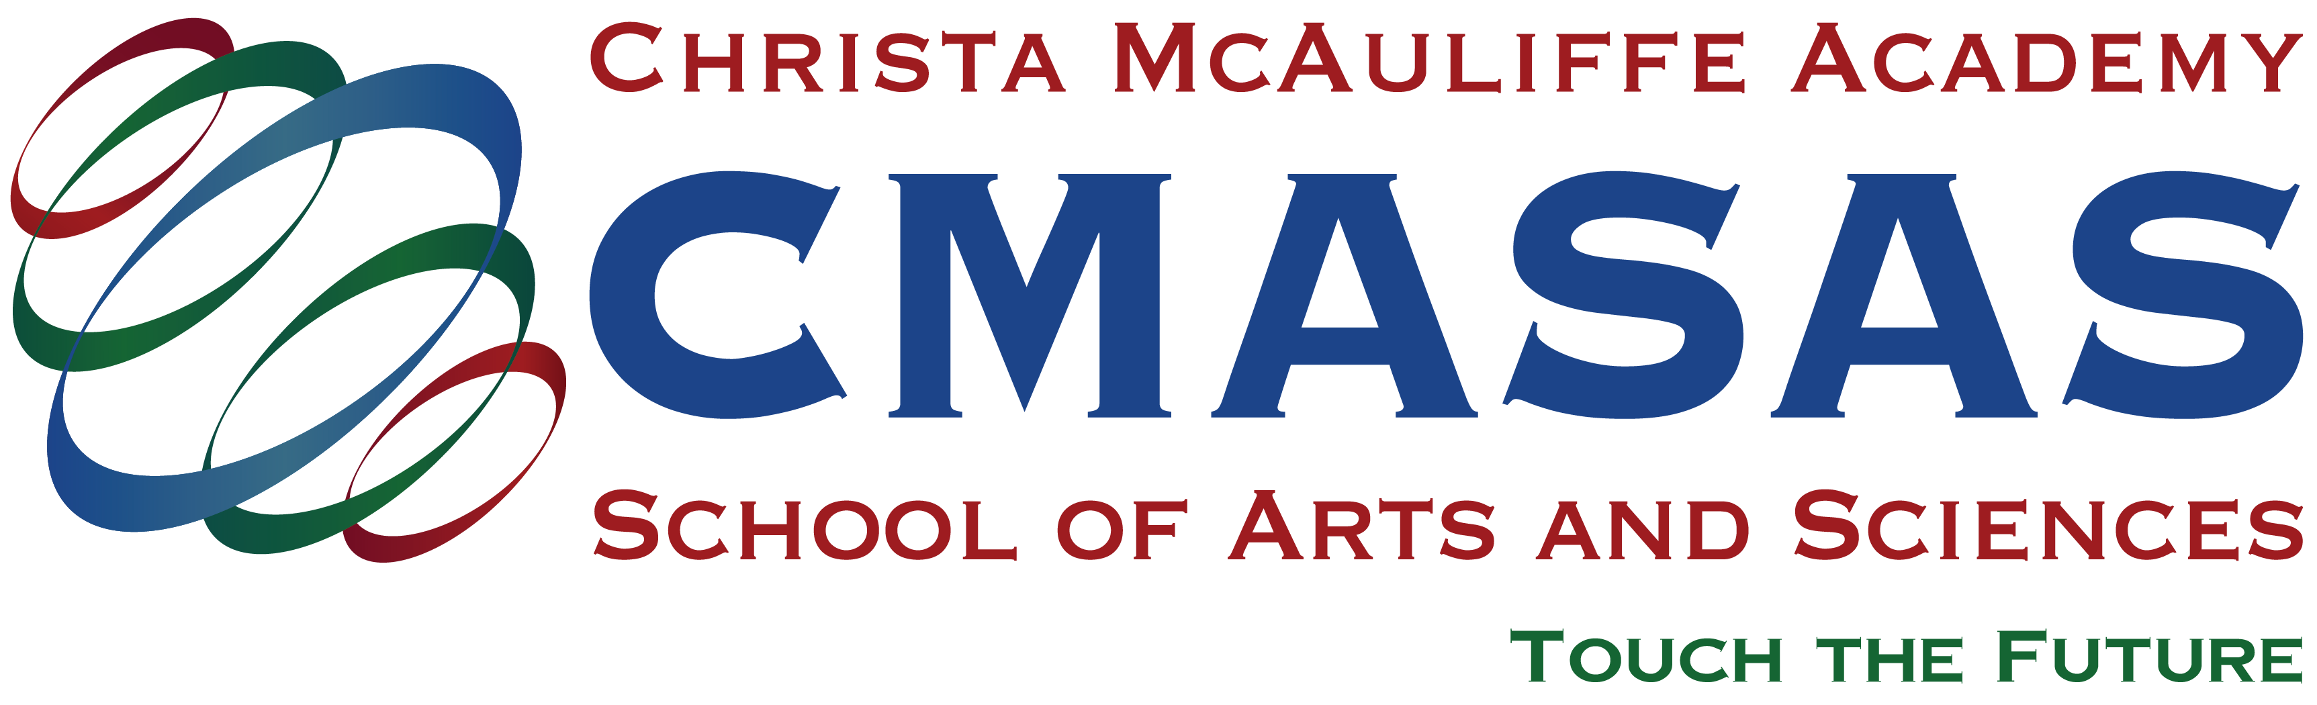

Parent Student
Handbook
(Texas Education Freedom Account Handbook)

Table of Contents

School Information 5
About Christa McAuliffe Academy School of Arts and Sciences 6
History 7
Mission 7
Accreditation 7
Leadership 8
Certificated Teachers 9
Personalized Education Coaches (PECs) 9
Course Instructors (CIs) 9
Parent Involvement 9
School Counselor 9
Student Life 10
PEC Weekly Homeroom 10
Homeroom and CI/PEC Appointment Guidelines 10
Clubs 10
CMASAS Travel Experiences 11
Regional Gatherings 11
CMASAS Student Honor Code 11
Technology & Systems 12
Learning Management System (Buzz) 12
Student Information System (Genius) 12
Diagnostic Skills Assessment (iReady) 12
Microsoft 365 & Teams 12
Technology Requirements 12
Student Learning & Planning Tools 13
Personalized Education Plan: All Grade Levels 13
Personalized Education Plan: High School 4-Year 13
Parent Observer Access 13
System Pacing Guides 14
Grade Reports 14
Progress Reports: High School Course Progress 14
Communication 14
Email 14
Telephone 14
Microsoft Teams 14
Getting Started at CMASAS 15
Enrollment Requirements 15
Upon Enrollment 15
First Week of Enrollment 15
Foundations in Personalized Learning 16
Second Week and Beyond 16
Top 10 Tips for Success 17
Student Coursework and Grading Policies 18
Student Coursework 18
Adequate Student Progress 18
Student Medical Leave Guidelines 18
Awards: High School 19
Grading Scale 19
Grading Policies 19
Parent Involvement 20
Five Step Teaching Model 20
Parent/Guardian Strategies 20
Transcripts, Testing, & Graduation 22
Transcripts & Progress Reports: All Grade Levels 22
Graduation: High School Requirements 23
Graduation: Checklist 23
Early Graduation 23
College Entrance Exams – SAT, ACT, PSAT 23
Tuition 24
Tuition & Payment Options 24
Payment Plans 24
Supplemental Materials 24
CMASAS Policies 25
Academic Integrity Policy 25
Alcohol/Drug Policy 25
Harassment and Discrimination Policy 26
Abuse and Violence Policy & Resources 26
Virtual Meeting & Chat Policy 26
CMASAS Enrollment & Tuition Policies 27
Christa McAuliffe Academy School of Arts and Sciences Pledge 27
CMASAS Start Date 27
CMASAS Full-time Trial Enrollment Details 27
CMASAS Individual Course Trial Enrollment Details 27
CMASAS Course Drop Details 27
CMASAS Student Course Change Policy 27
Tuition Plan Change Policy 28
CMASAS Full-time Student Course Add Policy 28
CMASAS Course Rollover Details 28
CMASAS Enrollment Terms 28
Payment and Refund Terms and Conditions 28
CMASAS Tuition Forgiveness Policy 29
CMASAS High School Diploma Issue Policy 30
Texas Education Freedom Accounts (TEFA) Tuition Policies 30
Parental/Guardian Consent Policy 32
Acknowledgment and Receipt of Parent/Student Handbook 2026-2027 34

School Information

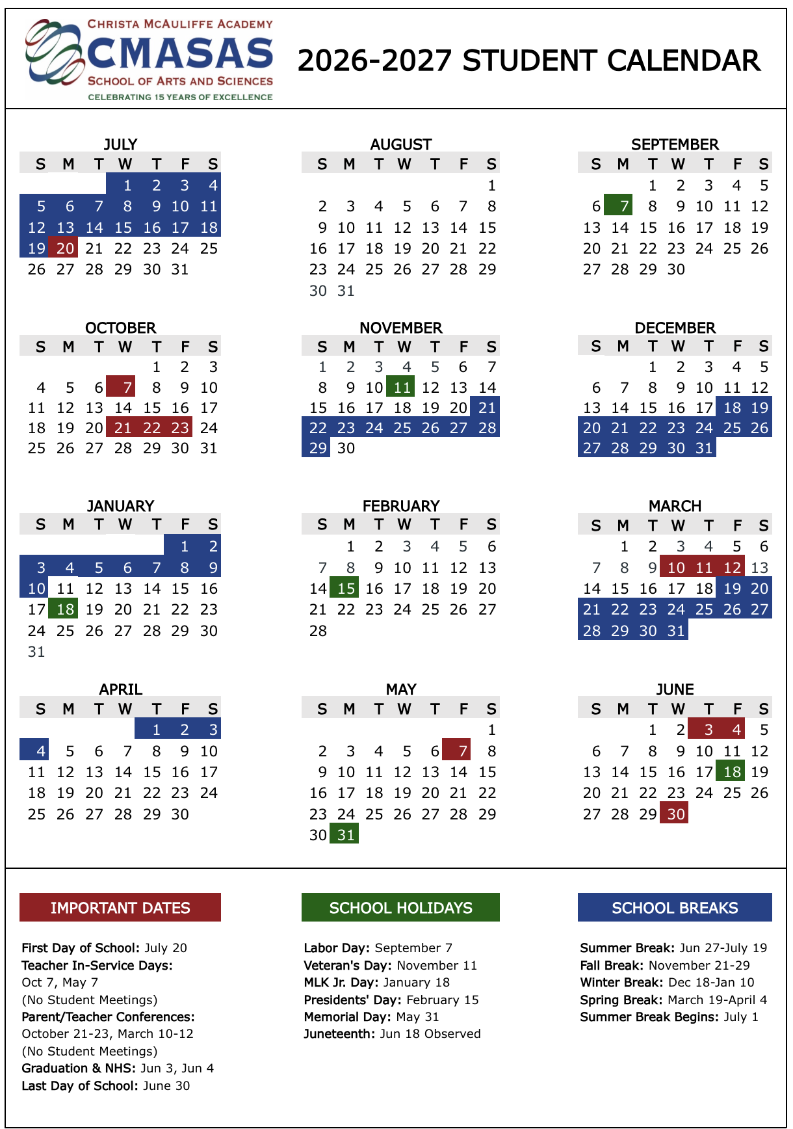

About Christa McAuliffe Academy School of Arts and Sciences

Christa McAuliffe Academy School of Arts and Sciences (CMASAS) is a K­12 private school. CMASAS emphasizes a personalized education/learning philosophy (Personalication) and offers a plethora of electives in the fields of arts and science, as well as other electives, which use computer courseware delivered over the internet. Student success is measured by demonstrating mastery at 80% or above for each course objective. Each student determines their own pace and learning preference, but mastery of each course objective is required to progress.

Every full-time student on a tuition plan is assigned a Personalized Education Coach (PEC). PECs provide academic assistance, counseling, guidance, encouragement, assessment, and caring support to students. Students stay with the same PEC from year to year, which is an essential aspect of our school. As a result, close relationships are formed.

CMASAS PECs use virtual homeroom classes for group discussion and interaction with students. The virtual homeroom is an advanced technology system, which we use to conduct scheduled weekly online meetings for all full­time students. Homeroom provides ample opportunity for students to learn and exchange ideas, to practice communication skills, and to get to know each other and their PEC in real time. It also provides opportunities for students to share passion projects and take part in meaningful discourse with other students.

Another essential component of the CMASAS model is the concept of parent involvement in the learning process. We expect a commitment from students and parents to accept responsibility for learning outcomes. Students are empowered to learn at their own pace, so they must take responsibility for setting and maintaining appropriate study habits and schedules. Parents must take an active part, monitor daily progress and give encouragement and support when needed.

When circumstances allow, the school offers an optional, extra cost program called CMASAS Travel Experiences, where students travel to important historical sites and exotic locations around the world. This program is designed to develop student awareness of cultural diversity and to introduce real-life experiences into the curriculum. Our website and PECs can provide additional information about these travel experiences each year.

Our goal is to produce generations of excellent leaders, grounded in traditional skills, knowledge, and values, but also highly capable in the use of advanced technology, to help set the pace in the ever-changing society of the future.

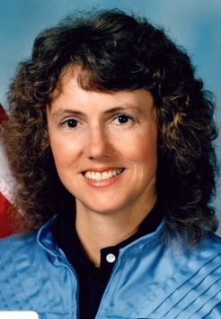
History
CMASAS was founded in 2009 and has grown from its rather humble beginnings into a thriving worldwide organization headquartered in the Pacific Northwest. CMASAS operates under Personalized Education Group, Inc., an educational management organization. Our knowledgeable, experienced, and passionate team of administrators, office staff, and educators foster a sense of community and an atmosphere of harmony where new ideas can take root and grow more easily and where innovation is welcomed and applauded.

CMASAS is named in honor of the late Christa McAuliffe. Inspired by her pioneering spirit, CMASAS views Christa as a role model for those promoting innovations in education to prepare students for the dynamic world.

Mission
To launch confident, caring leaders and passionate life-long learners who explore infinite possibilities, achieve their dreams, and touch the future.

Accreditation
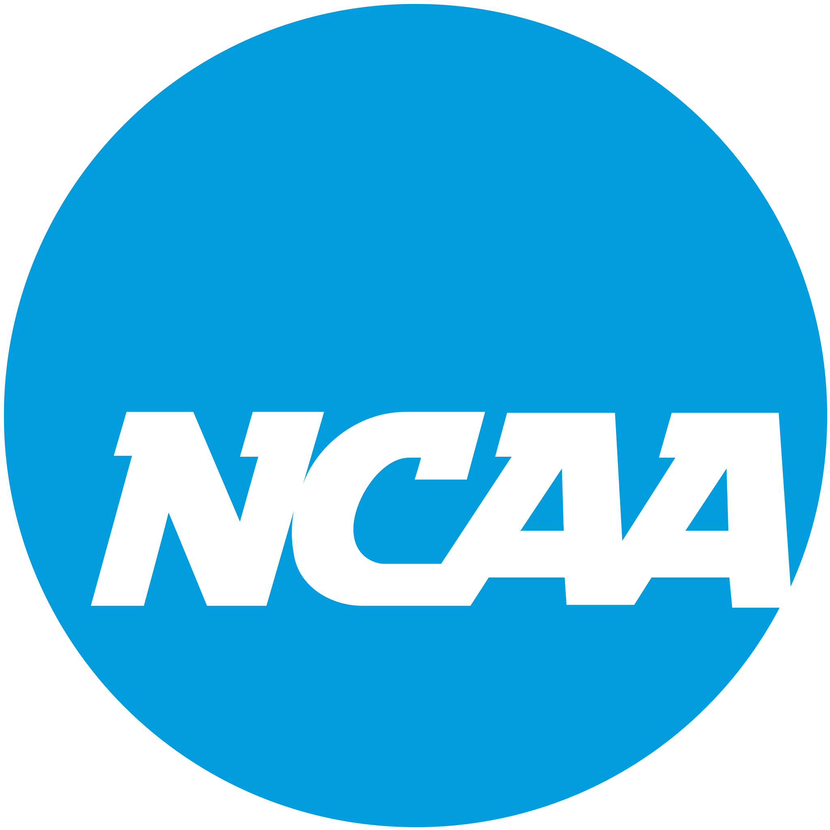

CMASAS is accredited by Western Association of Schools and Colleges (WASC), a global nonprofit that has the knowledge to help schools improve outcomes for all learners. Accreditation is a voluntary process which ensures schools provide high-quality learning opportunities and clearly demonstrates continual self-improvement. An accredited school is based on meeting specific criteria set forth by WASC.

CMASAS courses are also approved and accepted by the NCAA Eligibility Center for student athletes wishing to be eligible for and participate in collegiate sports.

Although we are fully accredited, students transferring from online schools may occasionally be asked for additional documentation—particularly if the receiving institution is unfamiliar with the program. To proactively address this, our student information system is designed to provide thorough, transparent documentation that supports a smooth credit transfer process. Students receive a highly personalized education, and it is recorded in a comprehensive manner that reinforces the credibility of their coursework and promotes recognition from colleges and universities.
Student Academic Team

Leadership
The leadership team works with all students and staff to ensure a well-rounded and successful school experience. They coach teachers and students on an as needed basis and regularly review student progress. The leadership team functions as the school's principal and works closely with all students' academic team members. They support PECs and CIs to aid in student success. They help develop the overall culture of the school and engage with the school community. The leadership team is comprised of:

 | 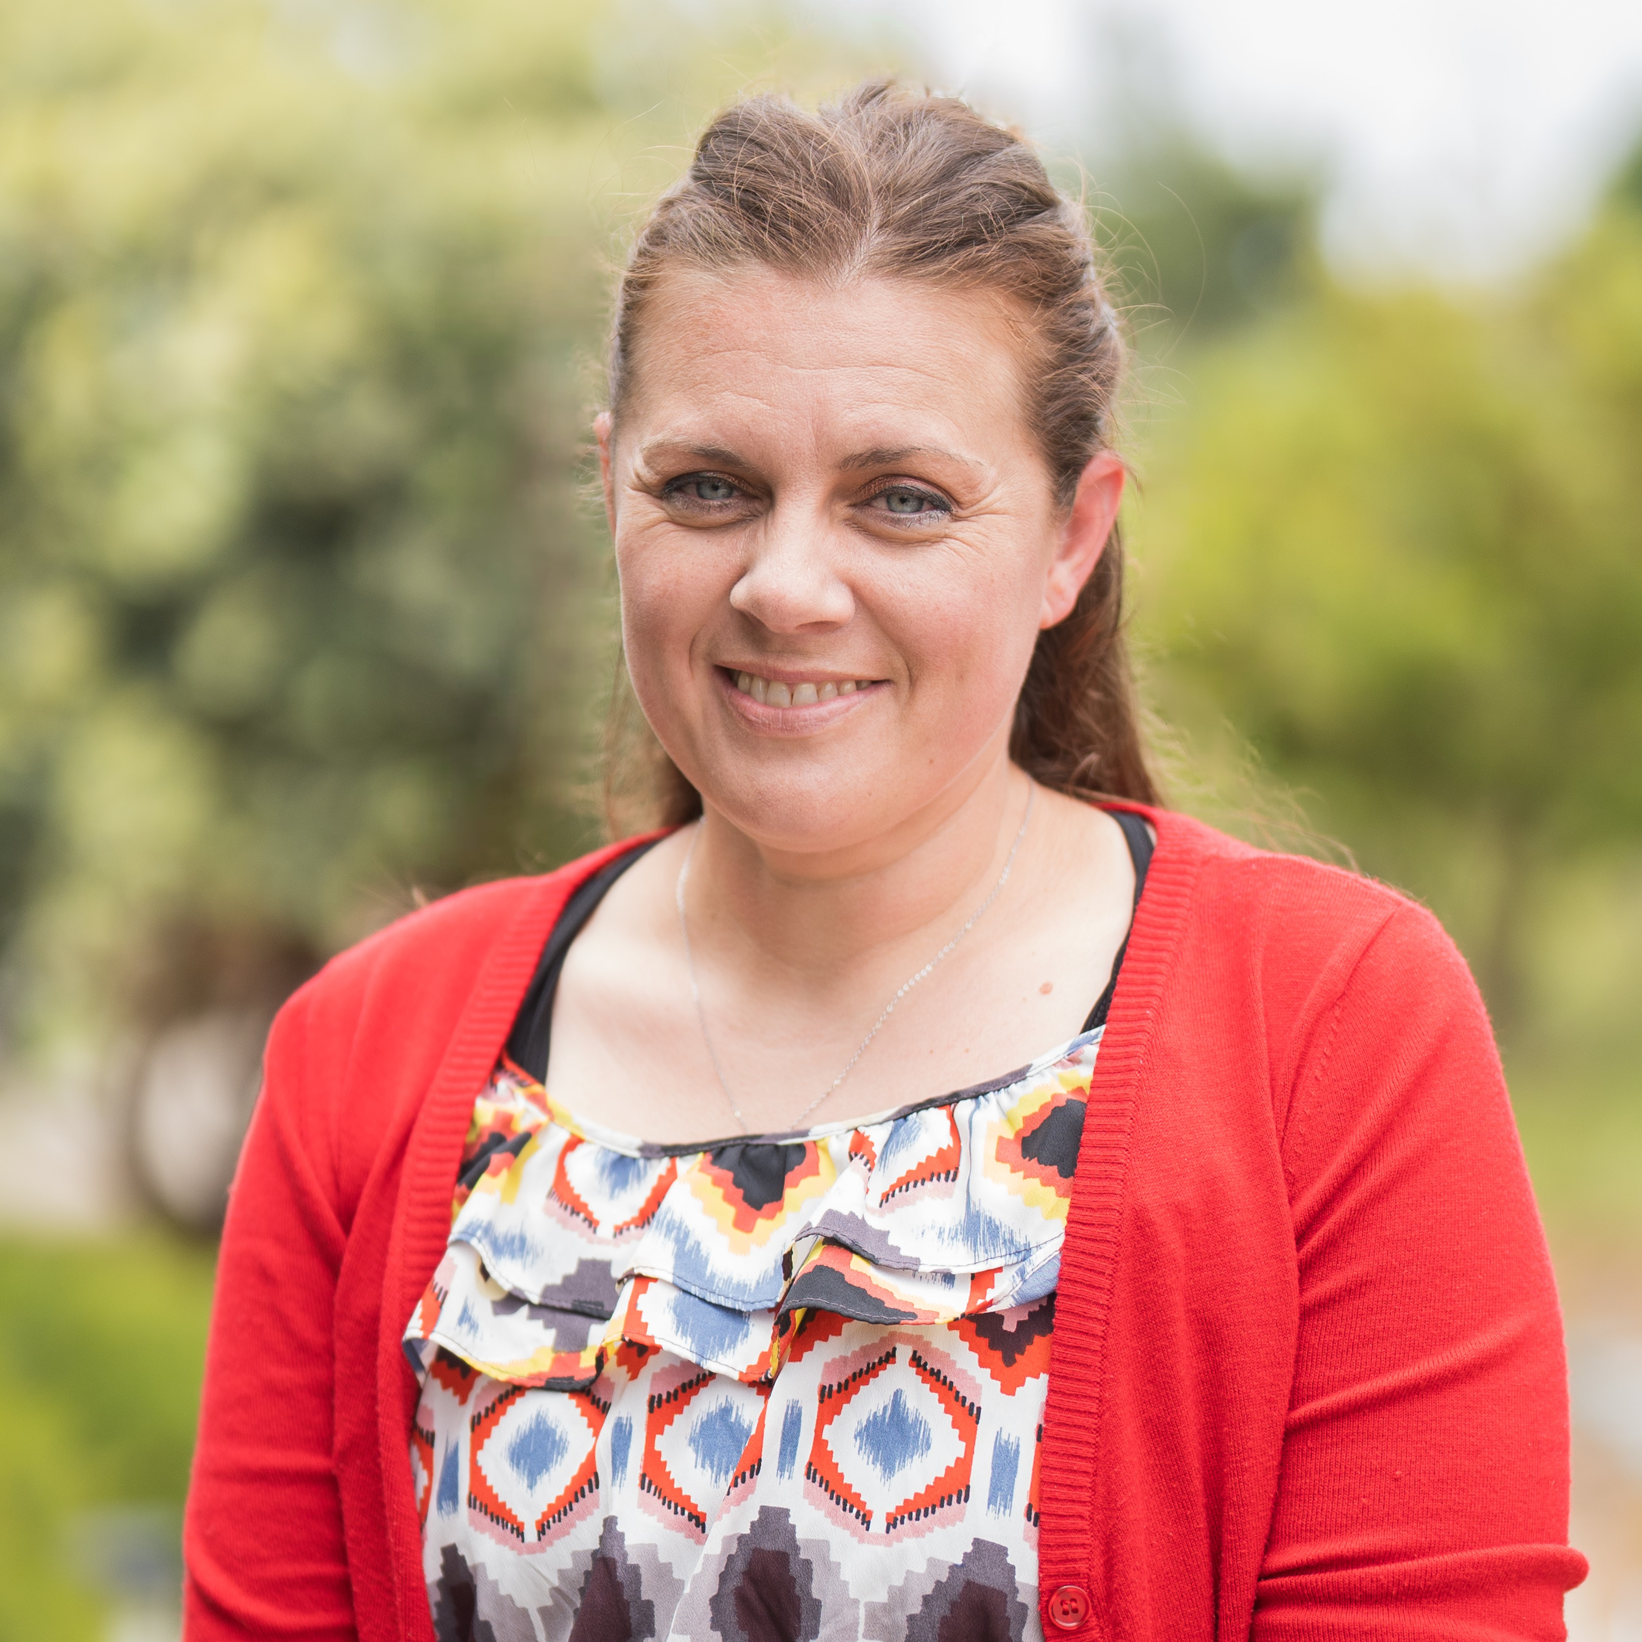 | 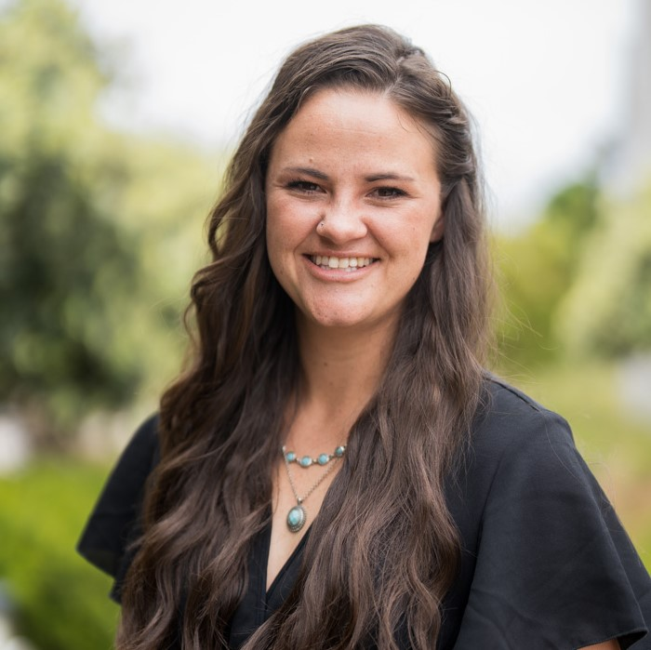 | 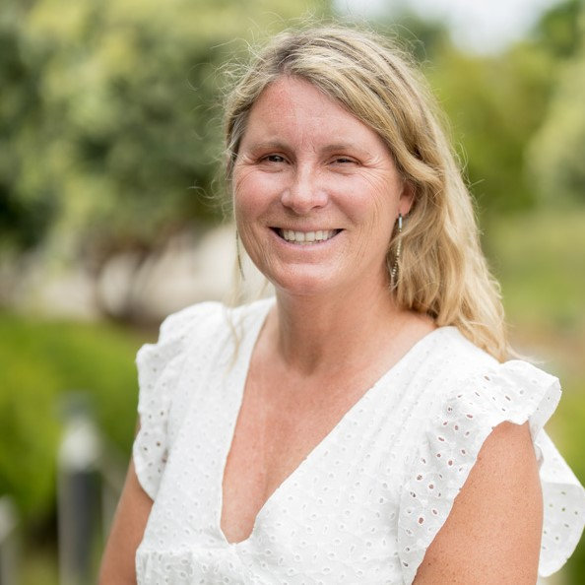
CHRISTOPHER GEIS  Executive Director | DAISY CHEATHAM  Elementary and Middle School Lead | CIERRA TREDWAY  High School Lead | HEIDI FOX  Director of Counseling
The Executive Director oversees the leadership team and ensures consistency in policies and vision. | The K-8 School Lead oversees PECs and CIs and are the main point of contact for staff and families regarding student success. | The 9-12 School Lead oversees PECs and CIs and are the main point of contact for staff and families regarding student success. | The School Counselor oversees the school’s Comprehensive Guidance Program to assure student success. This includes college/career counseling, individual planning, responsive services, and staff/faculty/student/family supports. The full description of the counseling role can be found on page 9.
 | 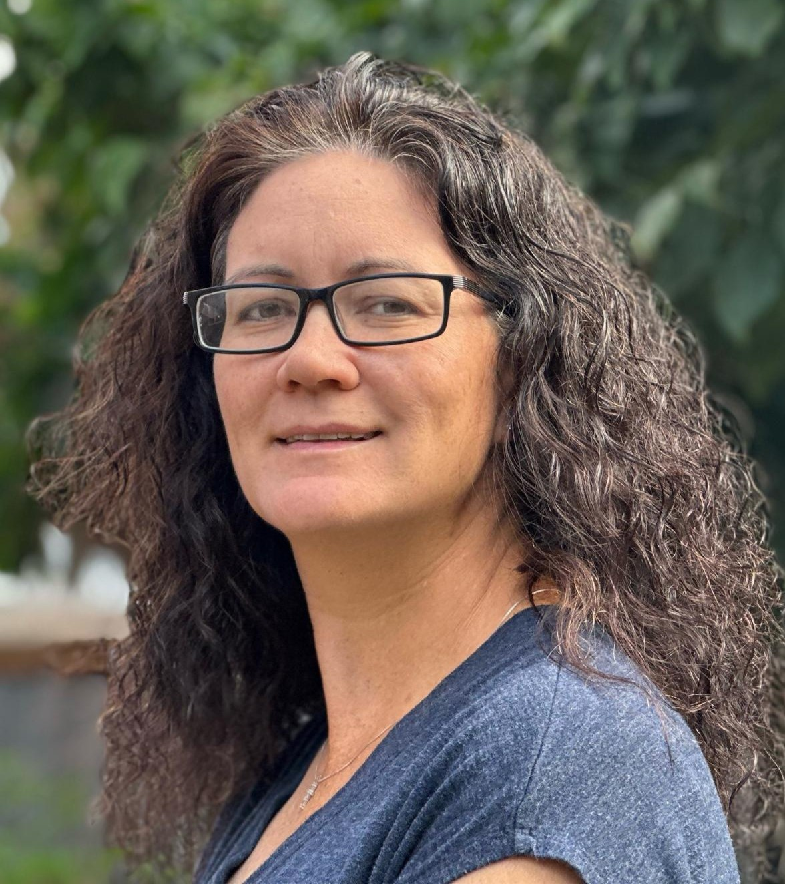 | 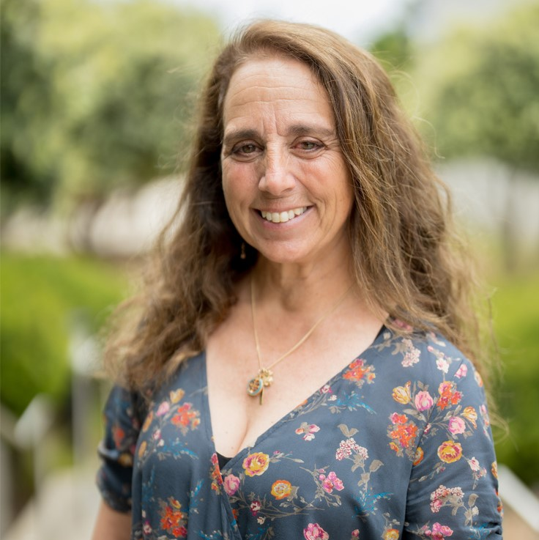
KIM FOWLER  Director of Curriculum | LINDA WHEELER  Director of Human Resources & Office/Account Finance | CATHY SPERRAZZO  Director of Marketing & Admissions
The Director of Curriculum oversees the design and creation of Personalized Education Group (PEG) curriculum and oversees/manages partner created curriculum. | The Director of Human Resources ensures a safe and productive environment for CMASAS staff. | The Director of Marketing and Admissions promotes CMASAS to prospective families in need of a personalized education option, supports families interested in enrollment, and ensures branding and consistent communications.

Certificated Teachers
All teachers are highly qualified, serving in their areas of specialization as deemed through certification, degree(s), and/or occupational experience. The two types of teachers are Personalized Education Coaches (PECs) and Course Instructors (CIs).

Personalized Education Coaches (PECs)
PECs are experienced advisors and mentors who take care of the whole child and serve students K-12, work one-one-one with each student to develop a Personalized Education Plan (PEP) tailored to their academic goals and learning needs.

PECs help students:
- Set goals and monitor progress
- Develop strong time management and study skills
- Create and follow a four-year academic plan aligned with graduation requirements
- Stay on track with course pacing, deadlines, and overall success

Course Instructors (CIs)
CIs are teachers who are highly qualified in their subject areas. They aid students working through a course. Instructors also coordinate with PECs to modify courses or even create custom courses designed specifically for students’ learning preferences and interests. CIs are available by appointment in their virtual classroom. CIs can also offer help via email, Microsoft Teams, and phone calls. Having access to highly qualified teachers in addition to their PEC increases student success.

CIs support learning by:
- Reinforcing, expanding, and personalizing the asynchronous curriculum
- Providing detailed feedback on assignments
- Meeting one-on-one to address specific questions or clarify concepts
- Offering flexible alternatives and enrichment options when appropriate

Parent Involvement
The CMASAS academic concept requires the active participation and supervision of a parent or other responsible adult for optimum achievement. Our experience and studies show that students who have the support and oversight from caring adults in the home are more successful and engaged in their learning experience.

Communicating with PECs and CIs is a critical component of student success, and parents/guardians are expected to take an active role in this communication. In the elementary program, parent involvement is especially critical because the parent takes on the role of day-to-day instructor to the student while the PEC provides the academic support
as needed for both parent and student.

School Counselor
The Director of Counseling oversees the school’s Comprehensive Guidance Program (CGP) and ensures that all staff and faculty are adequately trained to ensure student success. The school counselor will ensure that the CGP is being implemented in all aspects of learning at CMASAS. The four main components of the CGP are: guidance curriculum, individual planning, responsive services, and system support. Thus, the school counselor will ensure that all students at CMASAS have support for all aspects of the students’ and families’ academic and personal life. This may include such things as course planning, college prep and planning, standardized test prep and planning, support for learning disabilities, support for personal issues, help finding local support services, job/career planning and guidance, and much more. In short, by utilizing leadership, advocacy, and collaboration, the school counselor will promote student success, provide preventive services, and respond to identified student needs by implementing a CGP that addresses academic, career, and personal/social development for all students.

Student Life

PEC Weekly Homeroom
Homeroom is a weekly, online, interactive session. The primary purpose of homeroom is to provide students with a sense of belonging and a way to socialize and collaborate with peers and their PEC. In these sessions, the PEC answers questions about CMASAS and shares a discussion or project experience with students. Attendance during a homeroom session is not mandatory but is encouraged. PECs will email and/or call students who do not attend to connect and share information that was given in homeroom.

During these sessions, PECs will make school announcements. The rest of the homeroom is meant for students to socialize, share, and interact.

Homeroom and CI/PEC Appointment Guidelines
While each PEC and CI has specific rules and guidelines for their homeroom/office visits, the following is expected in every homeroom/appointment at CMASAS:

- If the CMASAS student comes late to homeroom, the student is welcome to join in the remainder of the session, but the PEC will not stay afterwards to review what was missed.
- The CMASAS student should strive to be on time for all appointments. If the student comes late to a CI/PEC meeting, the student will lose the time that they came late. For example, if a student is 10 minutes late for an appointment, the time spent with the CI/PEC will be reduced by 10 minutes. If a student arrives at an appointment more than 10 minutes late, the CI/PEC may opt to reschedule the appointment.
- If a student is unable to keep an appointment with a CI/PEC, the student should communicate that to the CI/PEC before the session begins.
- If a student cancels an appointment with a CI twice in the same week, the student will need to wait until the following week to schedule another appointment.
- At all times when taking part in our digital community, students are expected to follow the CMASAS Student Honor Code.

Clubs
Clubs at CMASAS are a great way for students to connect with other students who share similar interests. Like the PEC homeroom meetings, club meetings are scheduled in advance and held in Microsoft Teams. For a full, current list of clubs currently offered, please check with your PEC or the clubs page of the website, https://www.cmasas.org/clubs.

At CMASAS clubs are a privilege and not a right, and for students to participate in clubs, students must adhere to the following:

- Be enrolled in CMASAS as a full-time student
- Be in good academic standing
- Make adequate progress
- Regularly attend club meetings
- Abide by CMASAS Student Honor Code

CMASAS Travel Experiences
CMASAS Travel Experiences provides an exhilarating adventure for all students and parents! During this experiential learning opportunity, students complete several assignments based on the topic of the experience. Students get the opportunity to meet other students, go to remarkable destinations, travel, eat, and sightsee. They have a great time in a new land, exploring the culture and people. Please check with your PEC for more information if you are interested. This travel experience can also be used for a half credit elective. The availability of CMASAS Travel Experience will be determined on a year-by-year basis and based on current travel restrictions.

Regional Gatherings
A few times each year, CMASAS will organize gatherings around the U.S. with staff, students, and families from a local area. Past gatherings have included museum trips, bike rides, and even mushroom foraging! Any students who live locally or within a 2­3-hour trip to the destination city will be notified of the gathering. The availability of regional gatherings will be determined on a year-by-year basis and based on current travel restrictions.

CMASAS Student Honor Code

Our online school is a place for everyone, and we want all who join our school to feel valued. All students taking part in school activities are expected to follow the guidelines below.

- Global citizenship: Students are responsible for good behavior in our virtual hallways, just as they are in a classroom or a school hallway. Always use a computer in a way that shows consideration and respect. Students are not to use obscene, profane, threatening, or disrespectful language. CMASAS expects students to adhere to the local and country laws applicable to them.
- Act with academic integrity: Integrity and authenticity of student work is something that we take very seriously at CMASAS. Do not cut, copy, or plagiarize internet content or the work of your online classmates.
- Be mindful of copyrights: Just as copying someone’s writing is considered plagiarizing, so is the act of using someone else’s photo, comic, joke, or quote without giving proper credit to its creator or author.
- Be kind: Avoid posting comments or opinions that you would not feel comfortable speaking to someone directly and keep comments and subject matter appropriate. The internet is a very public forum.
- Don’t troll: Through forums, comments, and other feedback options, it is considered bad form to hijack conversation threads for personal gain, steer conversation towards off-topic subjects, or post inflammatory controversial rants or personal attacks towards another user to provoke and spur emotional responses.
- Consider consequences and protect yourself: Think about the social consequences of any publicly accessible online community forum or other program you interact with. EMAIL IS NOT PRIVATE. Never say anything online or via email that you would not want posted on the school bulletin board or published in the local newspaper.
- Be sensitive to privacy: Always limit your audience to a need-to-know basis. Don’t assume “Reply to All” is a useful tactic. Never disrupt the chain of command. While these things seem obvious, they happen frequently.
- Limit the spread of spam: Spam is the equivalent of junk mail that clogs email inboxes and offers little professional or personal value while potentially opening users to hacking.
- Use proper spelling and grammar: Though many liberties are taken with online word use, not all can follow a comment or conversation with little or no respect to the written word. Save acronyms, web jargon, and shorthand for its proper audience if it must be used at all.
- Exercise self-control and open-mindedness: All students should exercise self-control, think before speaking, and look for value in the opinions of others.
- Be respectful: CMASAS requires that all comments made and opposing viewpoints expressed be done in a non­confrontational and respectful manner.
- School policies: All students must follow CMASAS school policies listed at the end of the Parent-Student Handbook.

Technology & Systems

Learning Management System (Buzz)
Buzz is an online system where students access course content, receive and turn in assignments, and view their grades and teacher feedback. Parents are given an observer account to Buzz which allows them to see all course content, assignments, and grades for their student(s).

Student Information System (Genius)
Genius is a database used for managing student information and enrollments. PECs use Genius to generate student course plans, monthly progress reports, adjust course dates, and communicate with parents and students. Genius receives grade information from Buzz. Course Instructors finalize course grades through Genius which houses student transcripts.

Diagnostic Skills Assessment (iReady)
iReady is used for both formative and summative assessments for students in grades 2-11. Students can be assessed in language arts and mathematics. Based on the diagnostic skills assessment, a student’s placement in courses can be determined and additional instruction can be provided to fill any existing gaps in understanding.

Microsoft 365 & Teams
Each student is provided with a Microsoft 365 subscription upon enrollment. This subscription includes a school email address, Office Suite, access to Teams, and cloud storage space.

Teams are used as our virtual classroom for weekly homeroom meetings, office hours, and individual student meetings. Teams include whiteboard, voiceover IP, video, text chat, screenshare, file sharing, and other interactive features. Please note that while Teams is an official CMASAS platform and closed to public use, students are not supervised outside of official meeting times.

Technology Requirements
Sufficient technology and Internet access is required to complete online classes with CMASAS. The following list will help verify that you are adequately equipped.

Minimum Hardware Requirements:
- 3 GHz or faster processor
- 8 GB RAM
- At least 16 GB available hard drive space
Minimum Internet Requirements:
- DSL or cable highly recommended
- 1.5 mb/s Internet connection or faster

Operating System Requirements:
- Microsoft Windows 2000 or higher
- Macintosh OS X or higher
Browser Requirements:
- Google Chrome or Mozilla Firefox 3 (browser)
- Adobe Acrobat Reader

Specific curricula for courses may require additional software purchases. Any additional software requirements will be provided in the syllabi for your courses.
Computer specifications are reviewed and revised annually to accommodate changes in technology. Every attempt is made to ensure that these specifications satisfy all curricular needs for students completing courses.

While tablets, smartphones and other mobile devices may allow for some completion of coursework, they are not guaranteed to work in all areas. Please ensure you have a Windows or Mac-based computer available to complete coursework. Chromebooks are not recommended as they are not compatible with our systems.

SPAM Disclaimer: We do not promote or encourage the use of SPAM email, banner ads, or pop­up advertisements within our products.

Student Learning & Planning Tools

Student progress will be documented each month via the Grade Report (progress report) emailed at the beginning of each month through Genius. Apart from the formal report, PECs and CIs regularly look at areas where a student may need additional help in completing assignments and/or modifying existing assignments.

We use a set of forms to keep students, parents, and staff members informed on the annual goals and progress of each full­time student. The forms can be saved in pdf format and emailed to families upon creation or when changes have been made. If you have any questions, please contact your PEC directly regarding student progress.

Personalized Education Plan: All Grade Levels
The student course plan, or Annual Course Plan (ACP) for students on a year-long enrollment period, is created once per enrollment period and is stored in Genius. It is used to plan out which courses students intend on taking over the duration of their personal enrollment period. It is also part of documenting student progress. The course plan will list all the courses a student plans to take over the course of their enrollment period.

These are “living” documents in that they can be changed repeatedly throughout the year by the PEC. If a student decides not to take a course, it is deleted. If a student decides to add a course, it is added. The course plan can only include up to the total amount of credits/courses students can take during their enrollment period (i.e., 12 semester courses on a year plan or six semester courses on a semester plan).

Personalized Education Plan: High School 4-Year
The 4-Year Plan is created at the time of initial high school enrollment or upon entering the 9th grade and is reviewed on an annual basis to make any changes or updates as necessary. The 4-Year Plan covers either 20 or 24 credits depending on the diploma type selected, along with the number of years planned to complete those credits. A conventional 4-Year Plan would cover 24 credits over a 4-year period, that being 6 credits earned each year.

Neither the 4-Year Plan nor the course plan are required to be signed.

Parent Observer Access
Parents are provided with a parent account to both Genius and Buzz to stay apprised of student progress on a continual basis. Within Genius, parents can view an academic snapshot for each course, the student gradebook, student activity (time spent in Buzz), and contact information for the student's CIs and PEC. Within Buzz, parents can view all course content, assignments, assessments, the gradebook, and pacing guides for each course.

System Pacing Guides
Genius provides a real-time log of activity that allows students, parents, and PECs to determine if the student is logging sufficient time to reach their progress goals in each course. An academic snapshot located on the student/parent dash of Genius gives students and parents a graphic account of current progress. PECs and students discuss student goals in terms of course completion timelines, and PECs use these goals to establish a course end date entered in Genius.

Buzz uses the end date in Genius to populate an assignment "to do" list. This list provides assignment "deadlines" based on the number of assignments in the course and the desired end date. These deadlines are simply a mode of communicating the end date goal, and they should not be considered as hard and fast. They are merely guides. Buzz also provides a monthly calendar view of the "to do" list that allows students to see an overall monthly view of their assignments. Dates are listed next to each assignment in the gradebook section of Buzz.

Both Genius and Buzz pacing and progress guides are visible through student and parent access.

Grade Reports
The Grade Report is emailed to students and parents each month. It provides a monthly snapshot of progress for all courses and includes the current grade, number of completed assignments, and number of minutes logged for each course.

Progress Reports: High School Course Progress
Progress reports are sent bi-weekly for each individual course in which the student is enrolled. Progress reports include the course start date, number of assignments currently completed, number of total assignments in the course, and current end date of the course. Progress reports are a tool used in conjunction with the Grade Report and give students and parents a more frequent measure of formal progress.

Communication

There are several ways of communicating with your PEC, CIs, and other school staff.

Email
Email is the primary way to communicate with your PEC and CIs. For that reason, it is imperative that students and parents/guardians have a reliable, working email address that they check daily. It is a good idea to have an email address designated specifically for CMASAS/school communications. CMASAS provides students with an email address upon enrollment. If students opt not to use their CMASAS email address, they should forward messages sent to that inbox (meeting invitations, school announcements, etc.) to an address that they do regularly check. CMASAS will require two email addresses, one for the student and a separate one for guardian(s). Please be sure to provide both.

Telephone
Please be considerate of your PEC and CIs regarding phone calls. Remember that everyone does not live in the same time zone. Find out when it is a good time for your PEC or CI to receive calls. They will be delighted to talk with you. Any of our staff members can be reached by phone at (503) 226-7374.

Microsoft Teams
Another way to have a real-time conversation with your PEC and CIs is to download Microsoft Teams. Teams provides one location for chat, homerooms, and virtual live meetings. Try to be patient when contacting your PEC or CIs. They may be holding homeroom, meeting with an individual student, having a parent conference, etc. Leave a message, and your PEC or CI will get back to you as soon as possible within one business day.

Getting Started at CMASAS

Enrollment Requirements
Completing an online registration form allows our staff to initially place/enroll a student based on the personal information provided. In addition, the following items are part of the enrollment process and are required before placement in courses occurs:

- Registration fee payment and the entire or partial tuition payment
- Acceptance of payment and refund terms (completed upon checkout)
- Birth certificate or equivalent which matches the online registration form data and provides acceptable proof of age
- Student transcripts, if applicable (fulltime, 8th-12th grades)
- Release of student records form (If not fulltime, used to verify address)
- Signed agreement from the Parent/Student Handbook Agreement
- Signed Parent Consent Form (last page of the handbook)

Upon Enrollment
A PEC will be selected by our administrative team based on the enrollment application data and comments provided on the registration form, if there is no preference for a specific PEC indicated. In addition:

- Student details will be populated into our student information system, Genius, and our learning management system, Buzz.
- Students will be provided with a free Microsoft Office 365 account. This account includes a school email address, cloud storage, and the Office 365 suite of apps. This account will be used for virtual classroom meetings, homerooms, assemblies, clubs, and more.
- Students will be enrolled in Foundations in Personalized Learning course.
- A welcome letter email will be sent providing login information and contact information for your PEC and other staff members.

The PEC is notified by the administration of their new student. The PEC will contact new students/families within one business day of the enrollment start date. If they do not, please call the office to verify that the enrollment is complete.

First Week of Enrollment
Students will receive a welcome from their assigned PEC in the form of an email outlining specific details needed for starting the Foundations in Personalized Learning course. Students will also receive a welcome from our CMASAS student counselor and school Leads in the form of an email.

PECs will connect with the student/family through phone, or Teams, to personally welcome them to the CMASAS family, start building personal connections, and discuss courses of interest for the enrollment period. Students will start the Foundations in Personalized Learning course in the first days of their enrollment.

Foundations in Personalized Learning
This course is an introduction to our systems and prepares students to be successful learners in the online setting. High school students have the option to take this course for credit.

Elementary students will receive The 7 Habits of Happy Kids book written by Sean Covey. Students will use this text throughout the Foundations course to help build goal setting skills and establish good habits. Due to shipping restraints, international students will need to obtain their own copy of this book. As an alternative, international students will receive a pdf version of the book.

Students who worked through the Foundations course and implemented the recommendations from the course have done extremely well in their educational and life pursuits.

During the Foundations in Personalized Learning course students will determine their own unique learning preferences and complete the diagnostic assessment. Once the student has completed the learning preferences and diagnostic assessment, the PEC will go over the results with the student and parent/guardian. This may be done through the live online classroom, via email, teleconference, or Teams.

In addition, students will complete their course plan. High School will complete their 4-year course plan. Students will explore the online learning environment and become familiar with the tools available to foster and promote successful learning. Students will discover how to set goals and schedule their time. In addition, students will learn about CMASAS' policies and procedures and how to resolve technical issues.

Second Week and Beyond
During the Foundations in Personalized Learning course, students and parents work with their PEC to create a course plan. They then work together over the enrollment period to determine the sequence of courses to be taken throughout the enrollment. The PEC will request courses several days and up to a week prior to students needing a course in addition to Foundations in Personalized Learning.

The PEC continues weekly contact with students and keeps a weekly log of these contacts. PECs must have two-way regular contact regarding student progress to ensure that student needs are being met and to effectively mentor and advocate for each student.

Top 10 Tips for Success
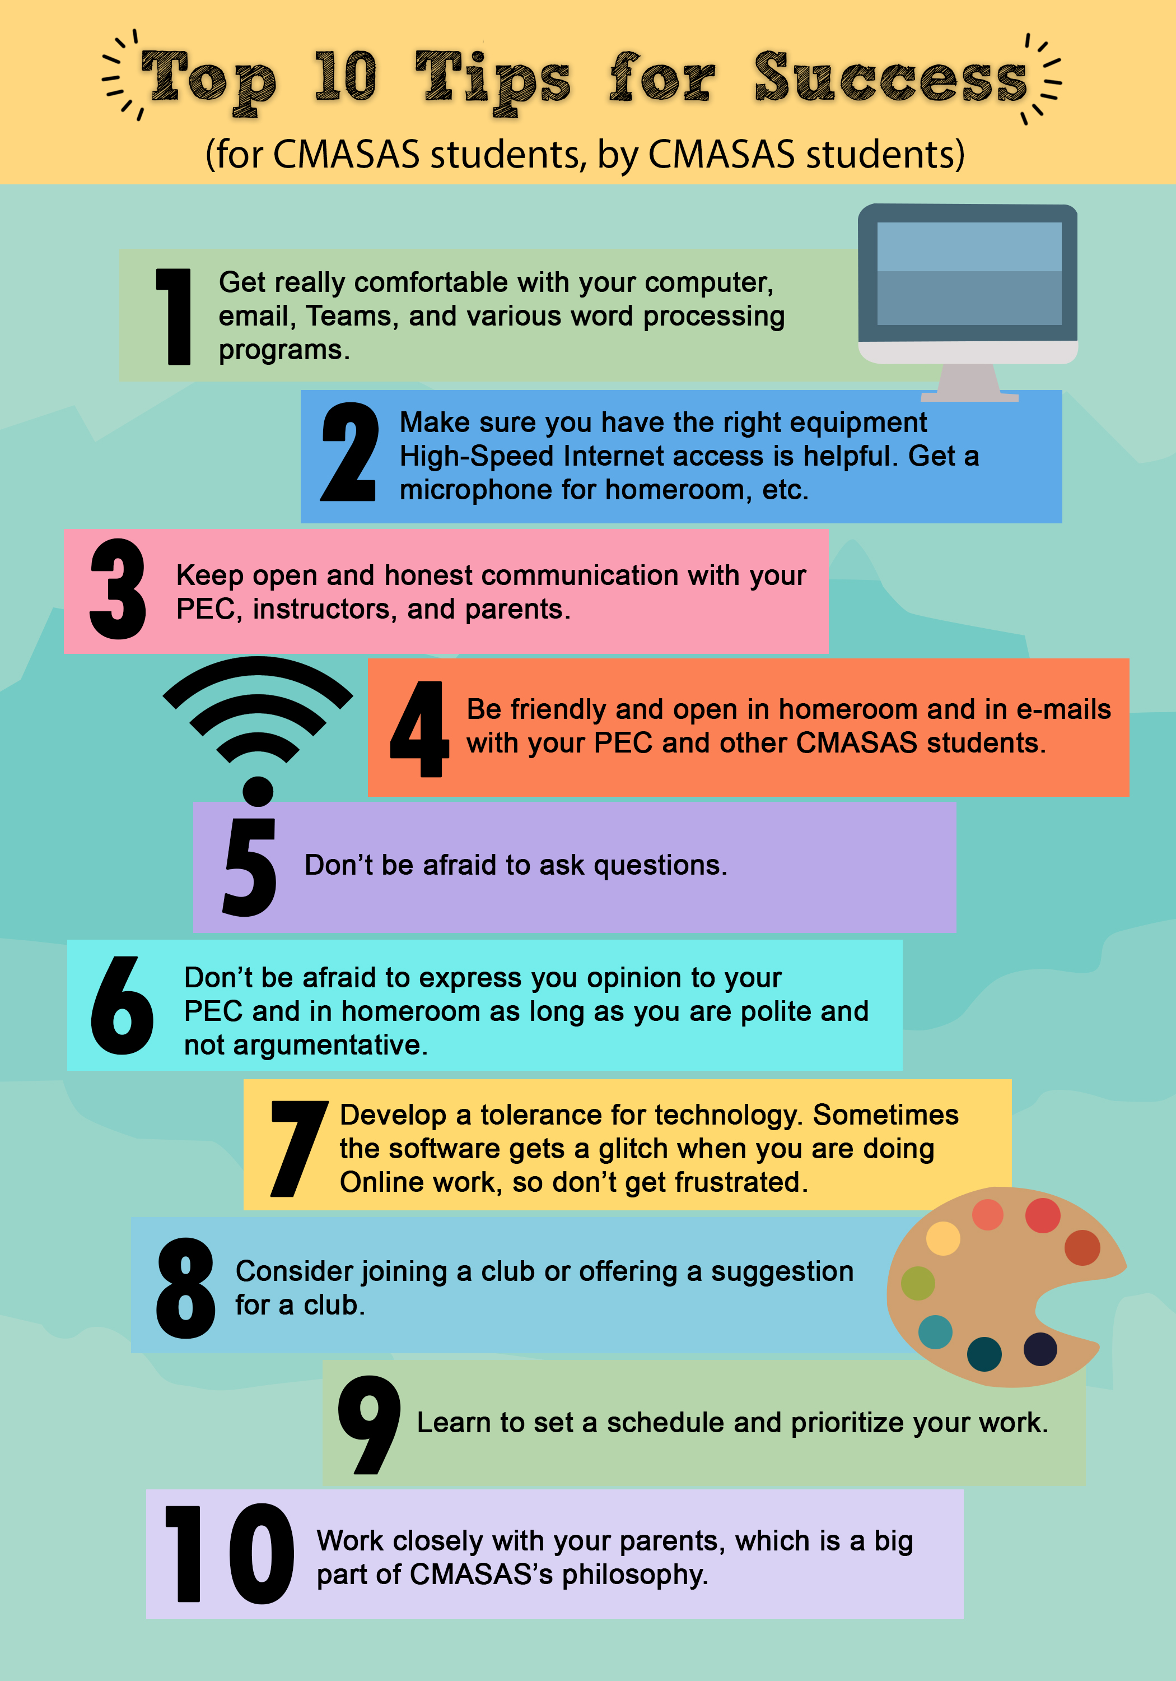

Student Coursework and Grading Policies

Student Coursework
Using student input, most recent grade level, available transcripts, and diagnostic/placement testing, the PEC assigns one to two core subjects to the student. Core subjects include math, language arts, social studies, and science.

It is recommended that a student spend approximately four to five hours per day on academic coursework, with additional time for non­academic, elective activities such as art, music, PE, and occupational education. High School Students, at this pace, each subject should take 4-8 weeks to complete.

CMASAS requires all students to obtain at least 80% mastery of all course objectives.
It is recommended that students who receive below 80% in their online coursework redo any lessons necessary to obtain an 80% score. As a result, students become confident of success, learn to excel, and most students complete high school well-prepared for post-high school endeavors.

Adequate Student Progress
CMASAS operates on a mastery-based instructional model rather than a strictly time-based system; however, students are expected to make regular, measurable academic progress in order to meet Adequate Yearly Progress (AYP) requirements and remain in good academic standing.

As a general guideline, students are expected to complete coursework at a pace equivalent to one semester course per month, unless an alternative learning plan has been approved. Regular login activity, assignment completion, and ongoing communication are essential indicators of adequate progress.

Parent, student, and Personalized Education Coach (PEC) communication is vital to meeting progress expectations. PECs provide families with tools to monitor student engagement and academic performance. Parents are strongly encouraged to maintain open communication with their assigned PEC and to notify them in advance when a student’s pace may be temporarily affected by circumstances such as travel, athletic competitions, health concerns, or artistic commitments.

PECs will actively monitor student login activity and academic progress. When a student demonstrates inconsistent participation, limited login activity, or insufficient academic progress, the PEC may:

- Establish assignment deadlines or progress benchmarks
- Collaborate with the student and parent to develop a revised learning plan
- Schedule required check-ins or interventions to support re-engagement

If a student fails to log in or make adequate academic progress over a sustained period and no communication or approved plan is in place, the student may be identified as not meeting adequate progress expectations, which could result in additional interventions or administrative review in accordance with CMASAS policies and state requirements.

CMASAS remains committed to individualized learning pathways. Students may progress from kindergarten through grade twelve at a pace aligned with their ability, motivation, and mastery, provided they demonstrate consistent engagement and measurable academic progress aligned with Adequate Yearly Progress (AYP) standards.

Student Medical Leave Guidelines
- The students’ enrollments may be placed on hold on a month-to-month basis.
- You would need to communicate with our Administrative Team each month to provide a status update and confirm whether the hold should continue. If our Admin team doesn't receive an update each month, the students could be automatically withdrawn for inactivity.
- A brief medical note from a licensed physician would be required, stating that the student is currently unable to complete schoolwork. The note does not need to include diagnosis or detailed medical information.
- This hold option would apply only through the end of the current enrollment term, which concludes July 26, 2026.
- Any time placed on approved medical hold would extend the course completion window accordingly. For example, if a student is on hold for two months, their course access would extend to September 26, 2026, to allow them to complete their coursework.

Awards: High School
The selection of valedictorian and salutatorian is determined by a committee that reviews student grades and other criteria. Along with GPA, the committee is looking for candidates with the following qualifications:

- Student must be within 2 credits of graduating by the end of April to be considered.
- Student has completed core academics through 12th grade.
- Student must be recommended by their PEC as having exemplary attendance and participation.
- Compilation, by student, documenting their role in community support projects, volunteer efforts, leadership, or any activity that shows outstanding effort and community or family involvement.

Students may also be considered for special awards to be given at graduation. Information will be sent out in the spring regarding graduation.

Grading Scale
Grades are determined on the standard CMASAS scale:

A | 95­-100% | 4.0
A­ | 90-­94% | 3.7
B+ | 87-89% | 3.3
B | 83­8-6% | 3.0
B­ | 80-82% | 2.7
NC | Below 80% | No Credit

Grading Policies
The PEC is required to send a Grade Report (progress report) to students and guardians monthly during enrollment period to keep students apprised of the grade they are earning.

The ability to make up given sections/assignments is up to the individual instructor. However, all make­up work must be done within the time the student is working on the course credit.
A course grade is given when all work is completed, and the objectives of the course have been mastered at 80% or above.

Remember that 80% is the lowest grade a CMASAS student can receive for a course. Anything below that will not receive a course grade. Students have ample opportunity to review lessons and improve scores and may retake courses to earn improved grades.

High School grades awarded for Honors courses, Advanced Placement, International Baccalaureate, and dual enrollment courses are weighted the same as other courses on the CMASAS transcript.

Parent Involvement

The CMASAS academic concept requires the active participation and supervision of a parent or other responsible adult for optimum achievement. Our experience shows that students need interaction and encouragement from caring adults in the home to succeed in their academic pursuits. Here are some ideas to help parents/guardians as they support their student(s).

Five Step Teaching Model
This is the model many teachers use in the traditional classroom. Families should personalize it to meet their needs.

- Set Up the Learning
  - Focus the student
  - State what will be learned (the objective)
  - Establish purpose
  - Establish transfer from past learning (if appropriate)
  - Pretest (if desired) to show what the student already knows
- Provide the Instruction
  - Provide the information
  - Model or prove examples
  - Check for understanding
- Guided Practice
  - Practice with the student
  - Elicit overt responses that demonstrate the learning outcome in the objective
  - Provide specific knowledge of results: “You’ve got it!” or “Let’s review this.”
- Reinforcement
  - Make final assessment to determine if the student met the objective
  - Have each student demonstrate learning on their own
- Independent Practice
  - Continue to monitor as the student practices independently
  - Provide immediate knowledge of results

Parent/Guardian Strategies
Often parents/guardians ask, “How does someone do this?” While online learning isn’t for everyone, it works for many families. Here are some useful tips for integrating online learning into the home learning environment.

- Assertive online school parents
- Provide relevant information to PECs and CIs that will help the student maximize their educational experience.
- Respond to the PECs and CIs communications in a manner to meet the students’ needs.
- Check email at least once per day to view communications between PECs/CIs and the student as well as bi-weekly individual course progress reports and monthly progress reports.
- Create a consistent learning environment.
- Clearly and firmly communicate how the student should behave and what they should do.
- Ensure that the student meets learning goals for each day and week.
- Back up words with actions.
- Communicate expectations to the student both verbally and visually. Post rules and consequences.
- Positive reinforcement
- Effective reinforcement of appropriate behavior is the key to dealing assertively with student behaviors.
- Verbal reinforcement guidelines
- Give directions to the student for expectations.
- Praise when they comply or listen.
- Positive notes are great on papers, post its, and even on the bathroom mirror!
- Ideas for positive rewards
- Certificates of achievement
- Positive notes
- “Free” time
- Grab bag of goodies (Keep giveaways and $1 store treats in a central location.)
- A point system for a larger long-term reward
- Tickets that can be saved towards the “purchase” of treats and prizes
- Star or sticker on a chart (works great with younger children)
- Lunch or special time just with parent or guardian (works well when you have more than 1 child)
- Park or special play place
- A coupon system
- A special visitor during “school” time, like a class guest in a “regular” class
- A party
- Setting limits
Discipline needs to be applied consistently. These suggestions may help set limits:
- Use comfortable, consistent consequences. Think before stating a consequence. Can it be followed through with?
- Provide the student with a choice. (Make sure all options are okay.)
- Provide consequences as soon as possible after the student chooses to disregard a request.
- Use a calm firm voice.
- Never punish the student severely.
- Behavioral changes take time and consistency. Behaviors aren’t developed in a day, and it will take longer for a learned habit to be changed.
Remember, negative behavior can come from:
- Frustration (Were the directions clear? Did the student understand? Did the receive praise?)
- Boredom (Is there variety? Is the work too easy? If there is not enough variety in the activities, check with the students’ PEC.)
- Lack of success (Is the learning too difficult? Does the PEC have suggestions? Is this objective appropriate for where the student is academically? Does the work need to be modified?)
- Personal problems (Is there something unresolved in the family or with friends that needs to be discussed/worked out so the student can concentrate on learning?)
- Suggestions for negative consequences
- Loss of free time
- Removal from activity (make sure students go to a place that is not stimulating)
- Letter of apology
- Student states 5 reasons why the behavior wasn’t acceptable
- Isolation or time out area
- Loss of privileges
- Changing behaviors
Behavior can be changed through the strategies used in formal and informal instruction including the following:
- Know when to react or not to react to what the student says or does. Choose battles wisely!
- Vary the use and sequence of materials and activities used in home education.
- Increase the rate or improve the quality of positive behaviors the student already possesses.
- Support the student's effort to behave well.
- Support the rules and reasons behind them.
- Ensure that the student perceives care and love; it’s the behavior that needs to be changed.
- The student needs to understand that parents/guardians are concerned about their growth.
- The student should understand that parents/guardians have their best interest at heart.
- When the student tests boundaries
- Support and follow rules and routines.
- Do not become an element of the inappropriate behavior.
- Parents/guardians are the major factor in the environment. They should take breaks where needed. The schooling environment will be stronger for it.
- Key points for successful discipline
- Firm but compassionate concern is the foundation for a positive relationship with the student while completing school at home.
- A positive relationship is much easier to develop with the student if parent/student behavior is consistent.
- Do not “play favorites” with students if working with more than one. Each student is an individual with a unique personality to celebrate.
- Ignoring inappropriate behaviors is sometimes the best way to decrease them, but every student is different. Sometimes ignoring is an invitation to form a habit. Parent/guardians must know which response works best with their student.

Transcripts, Testing, & Graduation

Transcripts & Progress Reports: All Grade Levels
Parents can track student progress, request progress reports and unofficial transcripts from their PEC, and enjoy other benefits of a professional student information system. Parents can request official transcripts through Parchment. Please ask your PEC or consult our school’s website for a link to Parchment.

Transfer Credits/Transcripts
If a student is transferring from another high school (or has taken any high school credit-bearing courses in middle school) we will request a transfer transcript for the student from his/her previous school/s. Only credits from accredited sources can be directly inputted into a student’s permanent/legal transcript in our system. Because we are an accredited program, we can only accept credits directly from other accredited programs. If a student plans to have any credits/courses/grades transferred in from non-accredited sources/programs (including homeschool, home-based programs, online formats that are not accredited, etc.) the students and family can request the “Non-Accredited Transfer Policy” information. This allows students to transfer up to a certain number of credits into our school by using an evaluation process we have set in place. There is a charge to the family for CMASAS to review and evaluate these non-accredited credits/courses/grades and have them placed officially into the student’s CMASAS transcript. These credits can be used only towards a CMASAS diploma and are non-transferable. For more information about transferring in from non-accredited sources, please contact our main office, your student’s PEC, or the counseling department.

Furthermore, students transferring in from international schools may need additional paperwork to document the accreditation from a foreign school. This includes (but is not limited to) translation from non-English based schooling. We do not provide translation services, but we can provide you with online services that can officially have these legal documents translated into English. Please note that the cost for the translation services for these legal documents will not be covered by CMASAS.

Graduation: High School Requirements
Twenty-four credits are required to earn the college prep diploma. Twenty credits are needed to earn the standard diploma. A student must complete a minimum of 25 percent of required credits with CMASAS to be eligible for a CMASAS diploma—thus, at least 5 credits completed at CMASAS to earn the standard diploma and a minimum of six CMASAS credits for the college prep diploma. Please note that a student can still gain admission to college with a standard diploma provided the student completes the correct minimum admission requirements in those 20 credits.

CMASAS plans to have an in-person graduation ceremony each year when possible. The date and location of the ceremony vary each year. Students planning on participating in the graduation ceremony need to be within two credits of earning their diploma by mid-May. They should have requested their final coursework and must RSVP their attendance by the required date, usually in March. Seniors who have already completed all requirements to graduate (i.e., graduated “early”) are also encouraged to attend and participate in graduation ceremonies. Seniors must have already paid the senior/graduation fee to participate in graduation ceremonies.

Parents/guardians are encouraged to pay the senior/graduation fee at the beginning of the senior’s school year. College application documents (including transcripts, letters of recommendation, and other required college app documents) will not be submitted until the senior/graduation fee is paid. The senior/graduation fee must be paid before the senior can be enrolled in their last course(s) needed to graduate.

Graduation: Checklist
The Graduation Checklist provides a guide to graduation requirements. It also serves as a tracking tool for monitoring and reporting progress. This checklist allows for addressing individual academic needs and individual choices. PECs have this checklist available for their students to use and help with planning all courses needed to earn the students’ diploma with CMASAS. This checklist can also help guide students and parents (in consultation with the PECs) in choosing the correct courses for a student’s chosen career path, college admission goals, life plans, and more.

Early Graduation
Since CMASAS’s programs are mastery-based and self-paced, it is possible to complete high school in less than four years. The amount of time it takes to complete the required courses for graduation depends on several factors, which depends on the student and their approach to completing their work. The student’s personal motivation and willingness to accept the primary responsibility for their academic achievements are key components. Other considerations that may affect the amount of time it takes to complete all the courses needed for graduation include, but are not limited to, the pace at which an individual student works, their abilities, personal interests, choice and difficulty level of electives, health and family issues, use of organizational and time management skills, etc.

Each semester course is designed to take approximately 90 hours of work to complete. It is expected that students will maintain a consistent school schedule by working on assignments between 20-25 hours each week. Because CMASAS is a year-round school, students can graduate at any time throughout the year (including summer). Each student will be considered part of a particular “graduating class year,” but again, they can graduate at any time throughout the year.

College Entrance Exams – SAT, ACT, PSAT
Check with the College Board website (for PSAT and SAT) and the ACT website for test dates, as well as where to sit to take the exam/s locally. Parents/students need to find a location near them (usually a local high school) that will allow the student to sit for these proctored exams. Additional information on tests will be sent to all students throughout the school year from the counseling department. Further information can be obtained by emailing the Director of Counseling. If the student needs accommodation/s for any standardized testing, please plan at least 3-6 months before the actual exam.

Parents/guardians must contact the Director of Counseling to proceed with submitting a request for testing accommodations related to disabilities, IEPs, 504 plans, etc.
CMASAS school code is 380581.

Tuition

Tuition & Payment Options
PECs do not handle tuition information and will refer parents/guardians to the CMASAS school office. If there are questions regarding tuition, please contact the office directly. For updated tuition information please refer to our school website.

Payment Plans
CMASAS offers a payment plan for semester or full year enrollments, or family can choose to pay in full. Individual Course enrollment tuition is due at time of registration.

Payment plans start on the first day of enrollment and each subsequent month on the same day. CMASAS does not send tuition statements. Payment plans are valid for active students. Any outstanding payments remaining for students who withdraw are due at time of withdrawal and will be deducted automatically. Student records will not be released until all outstanding balances have been paid in full.
Payment by Check:

Make checks payable to:
Personalized Education Group, Inc.
Send payments to:
Personalized Education Group, Inc.
5200 SW Meadows, Suite 150
Lake Oswego, OR 97035

Payment by Credit Card:
Parents/guardians may also choose to pay the monthly tuition by credit card, e-check, or bank wire. Please contact the main office with any questions regarding these tuition payment options.

Supplemental Materials
Most courses do not require textbooks or additional software; however, there are several that do require additional materials. For example, Advanced Placement classes will often require the purchase of a specific textbook, some science classes might require lab supplies, and some technology courses require software. Families may request documentation of academic standing to qualify for educational discounts.

CMASAS has also assisted families by purchasing materials and shipping them directly to the student. In these cases, an additional charge is made to the student’s billing information, and one must allow 2-4 weeks for processing and delivery of materials. Material sources to consider include the public library, the Internet, and Amazon, which has many new and used textbooks available for purchase.

Parents/guardians may also opt to supplement CMASAS curriculum options through curriculum they have purchased or engage in learning opportunities such as visits to science museums, zoos, historical sites, or other similar locations. Families are encouraged to work closely with their PECs and CIs in using these other curriculum and instruction options.

CMASAS Policies

Academic Integrity Policy
Academic integrity is founded upon and encompasses the following five values: honesty, trust, fairness, respect, and responsibility. Supporting and affirming these values is essential to promoting and maintaining academic integrity. Each member of the academic community must stand accountable for their actions. As a result, a community develops in which students learn the responsibilities of citizenship and how to contribute honorably to their goals and endeavors.

The first responsibility for academic integrity lies with individual students and faculty members of this community. A violation of academic integrity is an act harmful to all other students, faculty, and the school. Deceit and misrepresentation are incompatible with the fundamental activity of this academic institution and shall not be tolerated. Members of the Christa McAuliffe Academy School of Arts and Sciences (CMASAS) community are expected to foster in their own work the spirit of academic honesty and not tolerate its abuse by others. This Academic Integrity Policy encompasses the duration of the students’ enrolment with CMASAS.

Consequences are at the discretion of CMASAS and are dependent on the severity and type of violation to the academic integrity policy.

Students are expected to practice responsible and honest behavior. Acts of academic dishonesty will not be tolerated at CMASAS, and typical offenses are listed but not limited to the following:

- Copying material from other sources and claiming it as your own without citation.
- Soliciting answers from other students, online forums, or search engines.
- Intentional falsification or invention of date, citation, or other authority in an academic exercise.
- Taking someone else's work or ideas as your own, with or without their consent, by incorporating it into your work without full acknowledgement.
- Theft or alteration of materials.
- Unpermitted use of AI to produce assignment tasks or requirements.
Consequences for violations to the Academic Integrity Policy may include any of the following:

- The student may be issued a warning regarding the specific violation that was committed, and parent or guardian may be notified. The student may be allowed to resubmit the assignment with no loss of score due to the offense. However, the offense may be documented for future reference.
- The student may need to complete a plagiarism review course prior to completing any additional work or resubmitting the assignment. At the end of the plagiarism review course, the student will sign an acknowledgement form indicating they understand what plagiarism is and are familiar with the Academic Integrity Policy and agree to abide by the policy.
- An official letter may be sent home to explain the severity of the offense.
- The student may receive no credit for the assignment.
- The student may be placed on Academic Probation incurring an added tuition of up to $150.00 per month for 3 months or longer, and the offense will be documented in the student’s permanent academic records.
- Future assignments may be reviewed, and assessments may be required to be proctored at the family’s expense.
- The student may be removed from the course and receive a failing grade.
- The student may be withdrawn from CMASAS. (Payment and Refund Terms still apply)

Alcohol/Drug Policy
Use of and/or possession of tobacco products, drugs, or drug paraphernalia are not permitted on the CMASAS campus or at CMASAS-sponsored events.

Harassment and Discrimination Policy
CMASAS is committed to equal opportunity for all individuals in education. CMASAS programs and activities will be free from discrimination based on sex, race, color, religion, sexual orientation, national origin, physical or mental disability, or any other unlawful consideration. CMASAS expects students, parents/guardians, and staff to respect diversity.
Harassment definition: Harassment is unwanted and unwelcome behavior from other students, parents, or staff members that interferes with another individual’s life. When it is sexual in nature, it is “sexual harassment.” When it is racial in nature it is “hate-motivated behavior” or sometimes a “hate crime.”

Discrimination definition: Discrimination is negative or unfair treatment that brings discriminatory attention toward an individual based on race, ethnicity, sexual orientation, religion, or gender.
Failure to comply with this policy may result in dismissal from CMASAS.

Abuse and Violence Policy & Resources
Teen dating violence is unacceptable and is prohibited. Each student has the right to a safe learning environment.

CMASAS will provide an age-appropriate education about teen dating violence and domestic violence.
The procedure for employees to respond to incidents of teen dating violence that take place at the school—whether online, at school-sponsored activities, or in vehicles used for school-provided transportation—is to complete a mandatory reporting form and submit to the Director of Counseling.
Director of Counseling, Executive Director, Director of Human Resources, and each School Lead are responsible for receiving reports related to teen dating violence.

Per Oregon law, all students and families shall be notified of resources for National Domestic Violence, Sexual Assault, and Teen-Dating Violence. Students should reach out directly to a trusted staff member, the Director of Counseling, and/or call the numbers referred to below:

- National Domestic Abuse Hotline: 1-800-799-7233
- National Sexual Assault Hotline: 1-800-656-4673
- National Teen Dating Hotline: 1-800-331-9474 or visit https://www.loveisrespect.org/ for more resources

Virtual Meeting & Chat Policy
CMASAS uses online platforms to interact and communicate with students. To protect students and staff and to allow for asynchronous participation, group meetings such as homeroom and club meetings are recorded as standard procedure. Individual meetings between students and course instructors or PECs are also recorded for safety reasons and to allow for reviewing as an additional instructional tool for the student. Students or families may opt out of individual meeting recordings for a compelling reason. All recordings are stored in a secure location and access to the recordings is strictly limited.

CMASAS expects students to abide by the Student Honor Code when participating in group Teams chats. This includes clubs, homeroom, and all-school chats. Violations of the policy may result in loss of chat and/or club participation privileges.

In-Person Activity Requirements
Policy Summary: CMASAS students are allowed to attend fewer than five (5) in-person activities per school year due to the State of Oregon Public Health Division Immunization Program.

This policy ensures accurate reporting while maintaining compliance with health and safety regulations.

CMASAS Enrollment & Tuition Policies

Christa McAuliffe Academy School of Arts and Sciences Pledge
At CMASAS we get education. We understand that not all students learn the same way, at the same pace, and at the same time. We understand our model is different. Students and parents may need time to adjust. We back up our personalized education with a trial period for full-time enrollments. We allow students to rollover unused courses when renewing with continuous full-time enrollment. We also offer a tuition refund policy for individual course enrollments. Review our complete enrollment and tuition policies below.

CMASAS Start Date
CMASAS strives to accommodate requested start dates. The enrollment start date will be based on availability. The enrollment start date is the date a course is processed and available for student activity, regardless of the date a student logs in to begin.

CMASAS Full-time Trial Enrollment Details
If for any reason our Personalication model isn’t the right fit for your student, notify us before your student is enrolled in their 3rd course and within 20 school days of your enrollment start date. We will cancel your enrollment with no further tuition payment obligation. If paid in full, a refund will be issued less one monthly payment for the plan selected. Registration fees are non-refundable.

The trial period is for students who have not previously enrolled in CMASAS. The trial period ends upon enrollment of a third course including the Foundations in Personalized Learning course or the end of 20 school days, whichever is sooner. The parent or guardian must notify CMASAS of their intent to withdraw via the Student Withdrawal Request Form. Registration fees are non-refundable.

CMASAS Individual Course Trial Enrollment Details
We offer a full refund, less $200 per course enrollment within 20 school days of the enrollment start date. There is no refund after 20 school days of enrollment on individual course enrollments. Individual courses are non-transferable.

CMASAS Course Drop Details
A student has up to 20 school days to drop a course and not have it reflected on their academic record if they have completed less than 15% of the course. After 20 school days or over 15% completion, and through the enrollment end date, a student will receive a “W” for withdrawal for any dropped course. The student will receive an “I” for incomplete if they don’t complete the course by the enrollment end date. All courses reflected on a student academic record count toward their course enrollment credits.

CMASAS Student Course Change Policy
A student has up to 20 school days to drop a course and not have it reflected on their academic record. After 20 school days, and through the enrollment end date, a student will receive a “W” for withdrawal for any dropped course. The student will receive an “I” for incomplete if they do not complete the course by their withdrawal date.

A course change fee of $200 may apply to any course dropped regardless of the length of enrollment. All courses reflected on a student academic record count toward their course enrollment credits. This policy applies to dropping or adding Honors after a course has started and dropping AP courses after 14 days of enrollment.

Tuition Plan Change Policy
Tuition plan changes may be requested within 20 school days from the start date of the current plan. No changes will be allowed after this period.

CMASAS Full-time Student Course Add Policy
CMASAS reserves the right to limit student course enrollments within the final four weeks of an enrollment period unless a renewal has been processed. Students will be required to complete all current course enrollments prior to adding additional courses during this time.

CMASAS Course Rollover Details
Sometimes life gets in the way, and a student may not complete a full enrollment of 12 semester courses within a 12-month period. CMASAS allows students to rollover unused courses that are in progress and/or not used from one academic year to the next with continuous enrollment. Students access rolled over credits after having completed their current enrollment plan credits.

CMASAS Enrollment Terms
Full-Time Enrollment Terms:
Semester: Consists of a 6-month continuous term. (i.e., if enrollment start date is August 15th, 2023, the enrollment end date would be February 14th, 2024.)

Full-Year: Consists of a 12-month continuous term. (i.e., if enrollment start date is August 15th, 2023, the enrollment end date would be August 14th, 2024.)

Individual Course Terms:
Semester: Consists of a 6-month continuous term. (i.e., if enrollment start date is August 15th, 2023, the enrollment end date would be February 14th, 2024.) AP and dual enrollment courses are not available for individual course enrollment.
Full-Year: Consists of a 12-month continuous term from the initial date of enrollment. (i.e., if enrollment start date is August 15th, 2023, the enrollment end date would be August 14th, 2024.) AP and dual enrollment courses are not available for individual course enrollment.

Payment and Refund Terms and Conditions
ALL SALES MADE OUTSIDE OF THE UNITED STATES ARE FINAL AND NO REFUNDS SHALL BE MADE.

Registration Fee: CMASAS requires payment of a non-refundable annual registration fee for full-time enrollments.

Tuition: CMASAS provides two payment options for tuition:

- Payment in full at time of registration.
- Down payment at time of registration plus a payment plan. Prior to opening the final course for a student on a payment plan, no more than 2 monthly payments may remain. Parents may pay the difference between the outstanding balance and total of two payments at any time prior to the course being approved.

Tuition and all outstanding fees must be paid in full, to receive a diploma from CMASAS. Unofficial transcripts are verified prior to finalizing official transcripts based on courses fully completed and tuition paid and applied to each course. Courses where tuition has not been paid will not be included on the official transcript.

CMASAS Tuition Forgiveness Policy
Tuition Forgiveness Policy: When withdrawing a student from the school, the parent/guardian must complete the Withdrawal Request Form. “Withdrawal Date” is the electronic imprint date and time on the form submission. Any form submission with imprint time after 5 pm Pacific time will be considered as received on the next business day.

Full-Year Enrollments: If a withdrawal is submitted between days 31-90 families may be eligible for a refund between the difference of the full-year tuition and current semester tuition listed on our website based on the number of course enrollments. If the withdrawal is submitted after 90 days, no refunds will be given.

Semester Enrollments: If a withdrawal is submitted between days 31-60 families may be eligible for a refund based on the number of courses provided, length of enrollment, and whether the student has started them. If the withdrawal is submitted after 60 days, no refunds will be given.

Payment Plans: Payment plans are valid for active students. Any outstanding payments remaining for students who withdraw are due at time of withdrawal and will be deducted automatically. Student records will not be released until all outstanding balances have been paid in full.

THERE ARE NO REFUNDS ON MATERIALS PURCHASED AND ON ANY APPLICABLE SHIPPING CHARGES IF MATERIALS HAVE BEEN SHIPPED.

PERSONALIZED EDUCATION GROUP, INC. HAS NO OBLIGATION TO PROVIDE A REFUND IF YOU OR YOUR CHILD VIOLATES SCHOOL POLICY OR OTHERWISE FAILS TO COMPLY WITH ANY MATERIAL TERM OR CONDITION APPLICABLE TO YOUR ENROLLMENT.

Late Fee Policy: CMASAS regulations require that a late payment fee be charged to any family who is delinquent in paying tuition by the established due date. An automatic late fee of $20 will be applied to failed payment attempts 8 days after the initial failed payment. Student access will also be suspended if payments continue to fail 15 days after the initial failed payment, and a $40 reinstatement fee is required to resume student access. Access will be granted when all tuition due has been paid. The late fee will be added automatically and is non-refundable.

Payment Return Fee Policy: CMASAS requires a $20 fee for all return funds regardless of the reason. Student access will also be suspended if payments are not received within 8 days and a $40 reinstatement fee is required to resume student access. Payment must be made by credit card or wire with additional convenience fees.

Suspension and Termination: Personalized Education Group, Inc. may suspend course access to CMASAS students without notice if the student is on a payment plan, and we have not received payment for service or payment has been declined. In addition, Personalized Education Group, Inc. may terminate any enrollment if student and/or guardian breach or otherwise fail to perform any material obligation. A reinstatement fee of $40, in addition to past due tuition, will apply to any student whose account has been suspended. Any terminated account must complete a new enrollment registration at current tuition rates in addition to paying tuition which is past due. Registration fees apply to all enrollment registrations.

Collection Costs and Attorney Fees: If any unpaid registration fees or tuition are sent to collections, or if an arbitration, suit, or action is instituted to interpret or enforce the provisions of this Agreement, to rescind this Agreement, or otherwise with respect to the subject matter of this Agreement, the party prevailing on an issue will be entitled to recover with respect to such issue, in addition to all collection costs, reasonable attorney fees incurred in the preparation, prosecution, or defense of such arbitration, suit, or action as determined by the arbitrator or trial court, and, if any appeal is taken from such decision, reasonable attorney fees as determined on appeal.

Arbitration: Any dispute, controversy, or claim arising out of or relating to this Agreement will be settled by arbitration. The exclusive arbitration forum, and venue for any disputes, will be the Arbitration Service of Portland, Inc. in Portland, Oregon. Judgment on the award rendered by the arbitrator may be entered in the circuit court in the county in which the arbitration occurs, and the resolution of the disputed matter as determined by the arbitrator will be binding on the parties.

Governing Law: This Agreement will be governed by and construed in accordance with the laws of the state of Oregon, without regard to conflict-of-laws principles.

CMASAS High School Diploma Issue Policy
CMASAS diplomas will be mailed to the address on file in our student information system. It is the responsibility of students to provide CMASAS with a correct address for mailing diplomas. A fee of $175 will be charged if a CMASAS diploma needs to be reissued or re-mailed for any reason. Additional shipping and handling fees apply to all international deliveries.

Texas Education Freedom Accounts (TEFA) Tuition Policies

TEFA Payment Requests, Disbursements, and Course Access
Families participating in the Texas Education Freedom Accounts (“TEFA”) program are responsible for timely initiation of tuition payments through the Odyssey Parent Portal.
For each CMASAS tuition disbursement or payment due date, the parent/guardian must initiate the applicable TEFA payment request through the Odyssey Parent Portal and take all actions required for the payment to be approved and processed.

Installment payments must be submitted within fourteen (14) calendar days of the family’s receipt of the applicable Texas Education Freedom Account (TEFA) installment funds. If payment is not received within this timeframe, the student’s access to the school’s courses and services may be temporarily suspended until all outstanding amounts have been received and the student’s account is brought current.

If a payment was timely initiated by the parent/guardian and approved through Odyssey but remains pending solely because of Odyssey or TEFA processing time, CMASAS may allow the student to maintain course access while the payment is being processed, provided the family supplies reasonable documentation of the pending approved payment upon request.

All tuition and other amounts due under the applicable tuition plan must be paid in full before the student will be granted access to the final course included in the tuition plan. Access to the final course may be withheld until the account reflects a zero outstanding tuition balance.

Parents/guardians are responsible for monitoring their Odyssey Parent Portal, available TEFA balance, payment requests, and payment status. A delay, denial, insufficient TEFA balance, or other inability to use TEFA funds does not eliminate the family's contractual tuition obligation to CMASAS.

If TEFA funds are unavailable, insufficient, or denied, the parent/guardian may satisfy the amount due using personal, non-TEFA funds. Course access may remain suspended until the applicable tuition payment has been received or other payment arrangements have been approved by CMASAS.

Any suspension of course access for nonpayment does not constitute withdrawal from CMASAS and does not cancel or otherwise modify the family's financial obligations under the Enrollment Agreement. A family wishing to withdraw must complete the CMASAS Withdrawal Request Form.

CMASAS will not assess a TEFA-funded late fee against a student's TEFA account. Any fees or charges that are not eligible for payment with TEFA funds are the responsibility of the parent/guardian and must be paid using non-TEFA funds.

Repeated Failure to Initiate or Complete TEFA Payments
Families participating in TEFA are responsible for initiating and completing each required tuition payment through the Odyssey Parent Portal within the payment timeframe established by CMASAS.

If a parent/guardian fails to timely initiate, approve, or complete a required TEFA tuition payment within the applicable fourteen (14) calendar-day payment window on two or more occasions during an enrollment term, CMASAS may require the family to establish an alternative payment arrangement for future tuition obligations.

At CMASAS's discretion, the family may be required to:
- Pay the applicable tuition installment directly to CMASAS using personal, non-TEFA funds;
- Maintain a valid payment method with CMASAS for amounts not timely paid through TEFA; or
- Enter into another payment arrangement approved by CMASAS.
Any alternative payment requirement does not prevent a family from using available TEFA funds for future eligible tuition payments when permitted by TEFA rules. However, TEFA participation does not relieve the parent/guardian of responsibility for making payments by the deadlines established in the Enrollment Agreement.

If a family has been moved to an alternative payment arrangement because of repeated missed TEFA payment windows, CMASAS is not required to delay a tuition due date while the family waits for TEFA funds to become available or for a TEFA payment request to be initiated.

If payment is not received according to the required payment arrangement, CMASAS may suspend the student's course access until the account is brought current. Suspension of course access for nonpayment does not constitute withdrawal and does not cancel or reduce the family's contractual tuition obligation.

TEFA Processing Delays
A payment will not be considered a missed TEFA payment for purposes of this section when the parent/guardian timely initiated the eligible payment, completed all required actions within the Odyssey Parent Portal, and the payment remains pending solely because of TEFA or Odyssey processing.

CMASAS may request documentation showing that the payment was timely submitted and approved or remains actively in process.

Outstanding Balances
If TEFA funds are insufficient, unavailable, denied, or otherwise cannot be used to satisfy an amount due to CMASAS, the parent/guardian remains responsible for the balance under the Enrollment Agreement and must pay the balance using personal, non-TEFA funds.

Any outstanding contractual balance following a student's withdrawal, transfer, or change in TEFA participation will be handled directly between CMASAS and the parent/guardian in accordance with the Enrollment Agreement and applicable TEFA requirements.

Parental/Guardian Media, Photography & Student Recognition Consent Policy

CMASAS values and celebrates the accomplishments, experiences, and contributions of our students. From time to time, CMASAS may photograph, video record, or audio record students participating in school-sponsored activities, including regional gatherings, experiential learning trips, extracurricular activities, clubs, assemblies, graduation-related activities, and other school events.
CMASAS may also wish to recognize student achievements, showcase student work, or share photographs, videos, audio recordings, or other student-created content for educational, informational, community-building, recognition, or promotional purposes.

Information and Media Covered by This Consent
With parent/guardian consent, CMASAS may use or publish appropriate student information and media, including:

- Student's first name and, when appropriate, last initial;
- Photograph or image;
- Video recordings;
- Audio recordings or student's voice;
- Grade level;
- Student artwork, writing, projects, presentations, or other student-created work;
- Academic, extracurricular, athletic, artistic, community-service, or other achievements; and
- Participation in CMASAS programs, events, trips, activities, or experiences.

This consent does not authorize CMASAS to publicly disclose sensitive or confidential student information such as a student's residential address, personal telephone number, personal email address, medical information, educational records, or other confidential information that is not reasonably necessary for the authorized purposes.
CMASAS will also seek to avoid publicly sharing a student's precise location or travel itinerary in real time when doing so could create a safety or privacy concern.

Where Student Information or Media May Appear
If consent is granted, authorized photographs, recordings, student work, achievements, and related information may appear in CMASAS communications and media, including:

- CMASAS websites;
- Official CMASAS social media accounts;
- School newsletters and email communications;
- Yearbooks, memory books, graduation materials, and memory videos;
- School publications, brochures, advertisements, and promotional materials;
- Presentations, informational materials, and community outreach;
- CMASAS-managed video channels, including YouTube;
- News or media coverage of CMASAS-sponsored events; and
- Other school-related digital or printed communications.

Publicly available websites, social media platforms, and other digital services may be viewed, shared, downloaded, copied, or redistributed by third parties outside CMASAS's control. CMASAS cannot guarantee how information that has been lawfully published or shared publicly may subsequently be used by others.

Participation in School Activities
A student's ability to participate in CMASAS educational programs, regional gatherings, experiential learning activities, extracurricular activities, or other school-sponsored activities is not conditioned upon granting media consent.

If consent is declined, CMASAS will make reasonable efforts to avoid intentionally photographing, recording, identifying, or featuring the student in CMASAS-created public or promotional materials.
Parents/guardians acknowledge that CMASAS cannot fully control photographs, recordings, or postings independently made by other students, families, members of the public, news organizations, venue operators, or other third parties at events where photography or recording is permitted.
Certain CMASAS events, including graduation ceremonies and other designated events, may be livestreamed and/or recorded. Participation in these events will be governed by a separate Livestream and Recording Acknowledgmentprovided in connection with the applicable event.

Voluntary Consent and Revocation
Granting media consent is voluntary.
A parent or legal guardian may revoke consent at any time by providing written notice to CMASAS. Revocation will apply to future CMASAS uses after the school has had a reasonable opportunity to receive and process the request.

Revocation is not retroactive and does not require CMASAS to recall, remove, or destroy materials that were lawfully created, distributed, printed, published, or provided to third parties before the revocation was received and processed. Where reasonably practicable, CMASAS will discontinue future use of the student's identifiable image, voice, work, or information in materials controlled by CMASAS.

Parent/Guardian Consent
I acknowledge that I have read and understand the CMASAS Parent/Guardian Media, Photography & Student Recognition Consent Policy. I understand that granting consent is voluntary and may be revoked in writing at any time, subject to the terms of the policy.

Do you consent to CMASAS photographing, video recording, and/or audio recording your student and using your student's image, voice, approved student work, first name and/or last initial, grade level, participation, and achievements for the educational, informational, community-building, recognition, and promotional purposes described in this policy?

YES, I CONSENT

NO, I DO NOT CONSENT

I understand that if I select No, CMASAS will make reasonable efforts not to intentionally photograph, record, identify, or feature my student for the purposes described in this policy. I further understand that this does not apply to incidental appearances outside CMASAS's reasonable control or to designated livestreamed or recorded events for which CMASAS provides a separate notice and acknowledgment.

A selection of “Yes” is required for consent to be granted. If no selection is made, consent has not been provided.

Please complete the form on the next page and return to the school

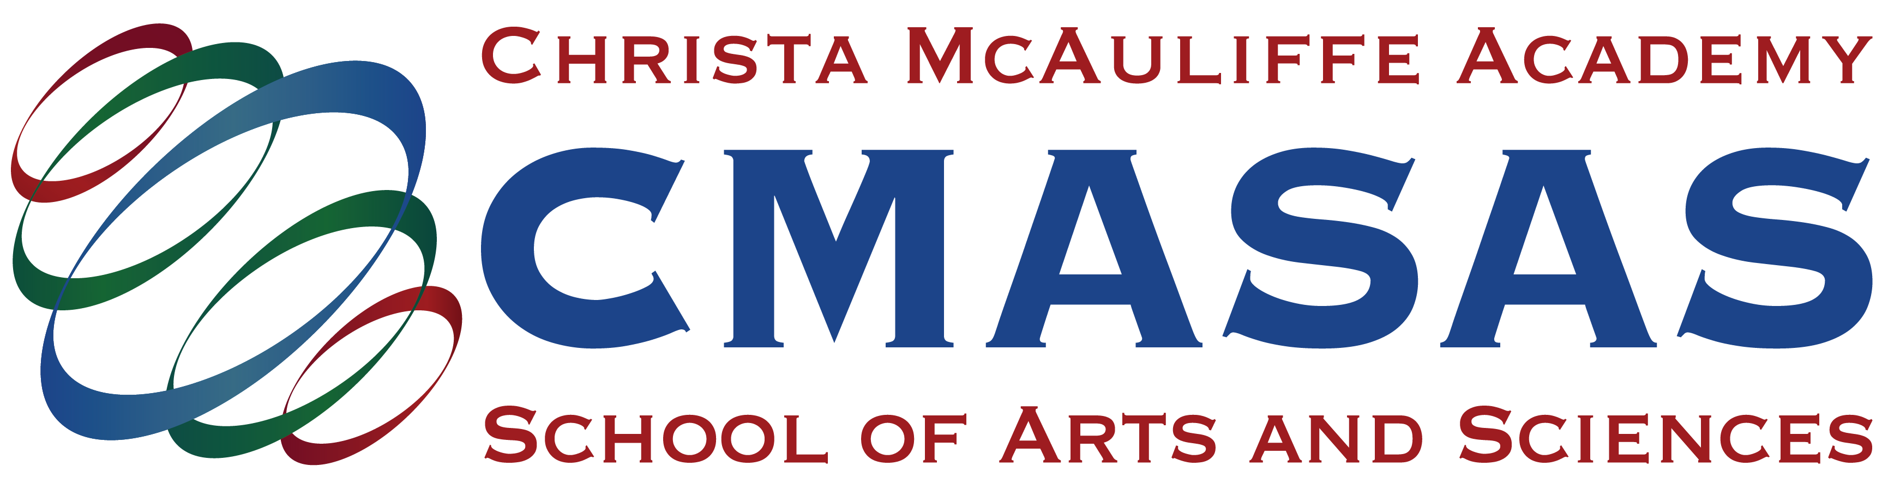

Acknowledgment and Receipt of
Parent/Student Handbook 2026-2027

I have received a copy of the Christa McAuliffe Academy School of Arts and Sciences Parent/Student Handbook. I have read and understand the contents therein. You represent that you have the power to bind the student(s) you enroll, and their parents and/or legal guardians, who shall be bound by these Enrollment and Payment Terms. By signing this document, I agree to comply with the rules, policies, and regulations set forth by Christa McAuliffe School Academy School of Arts and Sciences.

LIST ALL CMASAS STUDENTS IN HOUSEHOLD LEGAL NAME:
Student 1:
Student 2:
Student 3:
Student 4:
Student 5:
Student 6:

PRINT GUARDIAN NAME:
GUARDIAN SIGNATURE: DATE:

